**NAME:** Savan Yeshwanth Rao

**CSUID:** 2784780

**LAB- Ethernet and ARP Report**

1. The Ethernet address of my computer is: - **f8:34:41:5e:34:31**

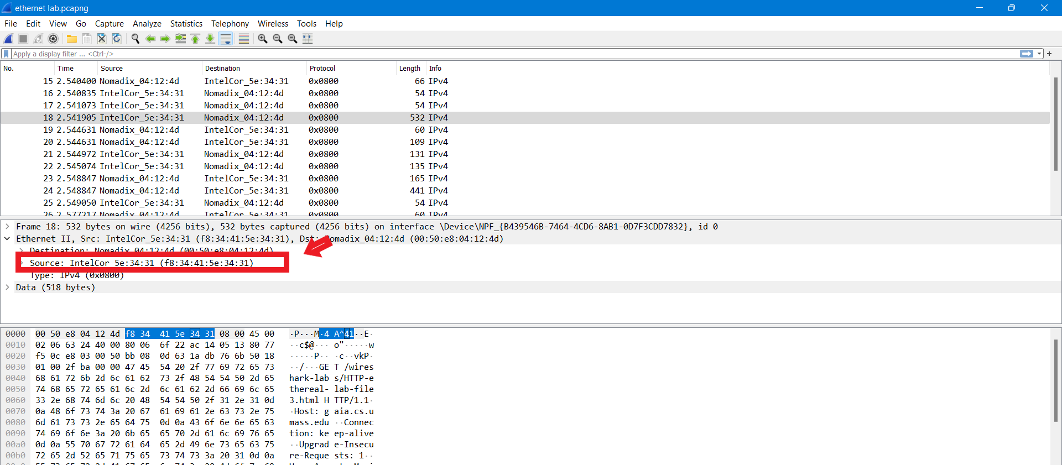

1. The destination address of ethernet frame is: - 00:50:e8:04:12:4d.

No, it is not the ethernet address of gaia.cs.umass.edu

It is the address of my Nomadix router, which is the link used to get the subset.

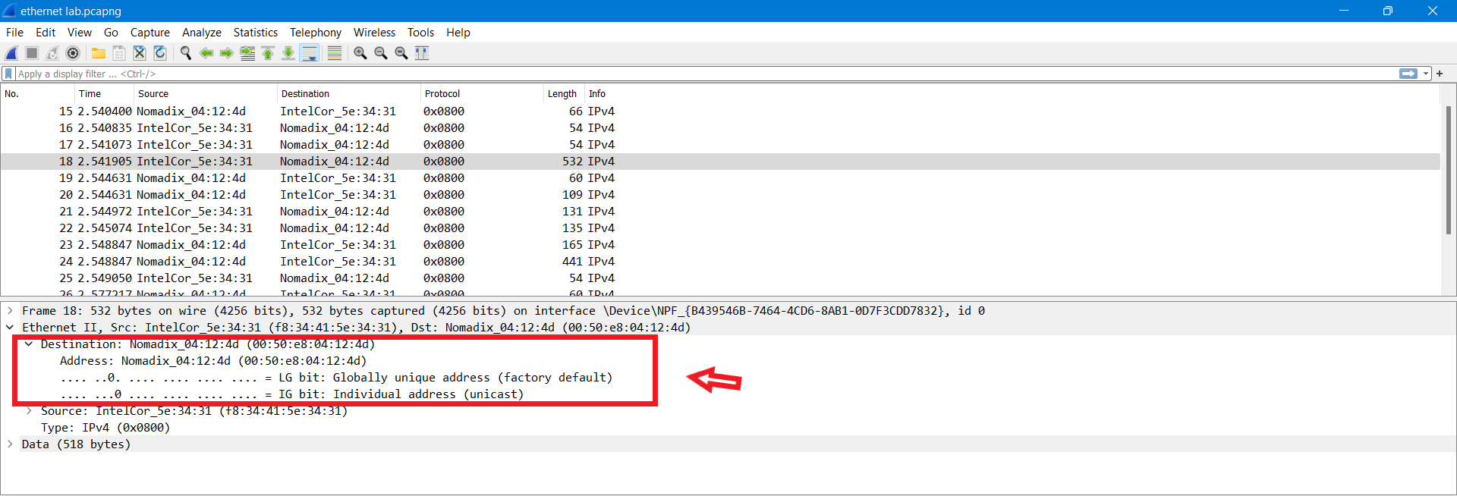

1. The hex value of the frame type field is **0x0800**. This corresponds to **IP protocol**.

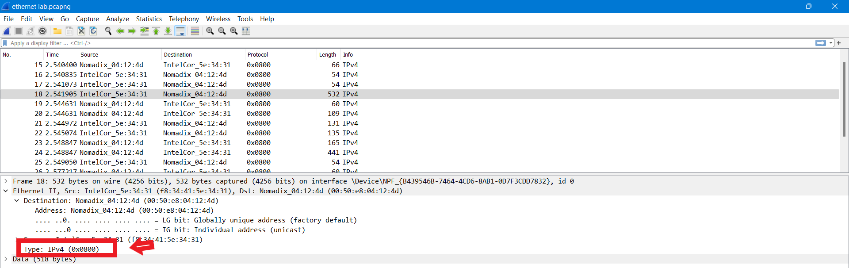

1. The ASCII ‘G’ has 47 bytes from the start of the Ethernet Frame.

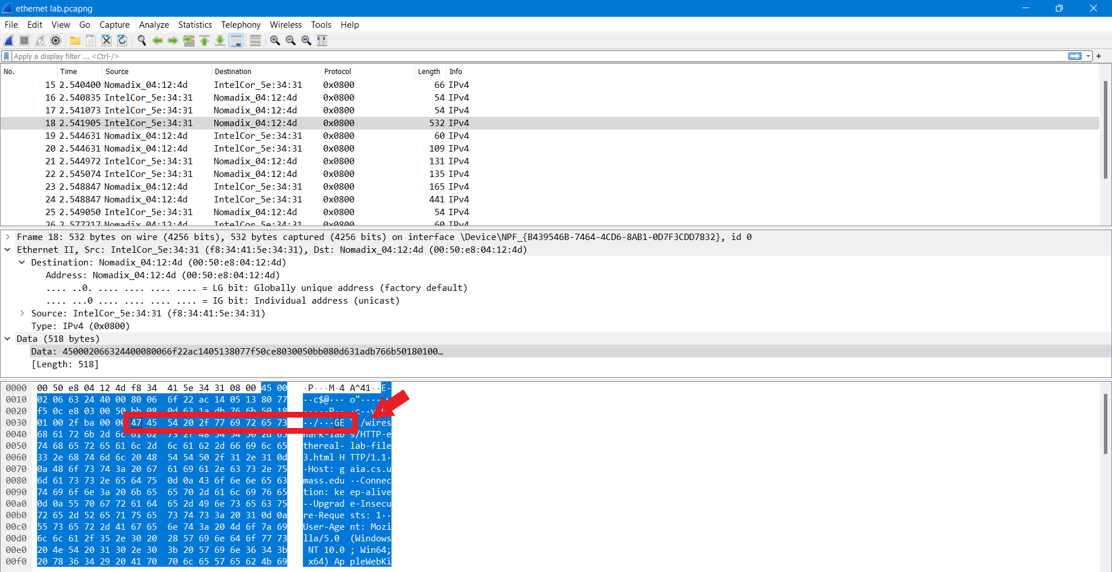

1. The value of Ethernet source address is: - 00:50:e8:04:12:4d

No, it is not the address of my computer. It is the address of Nomadix router

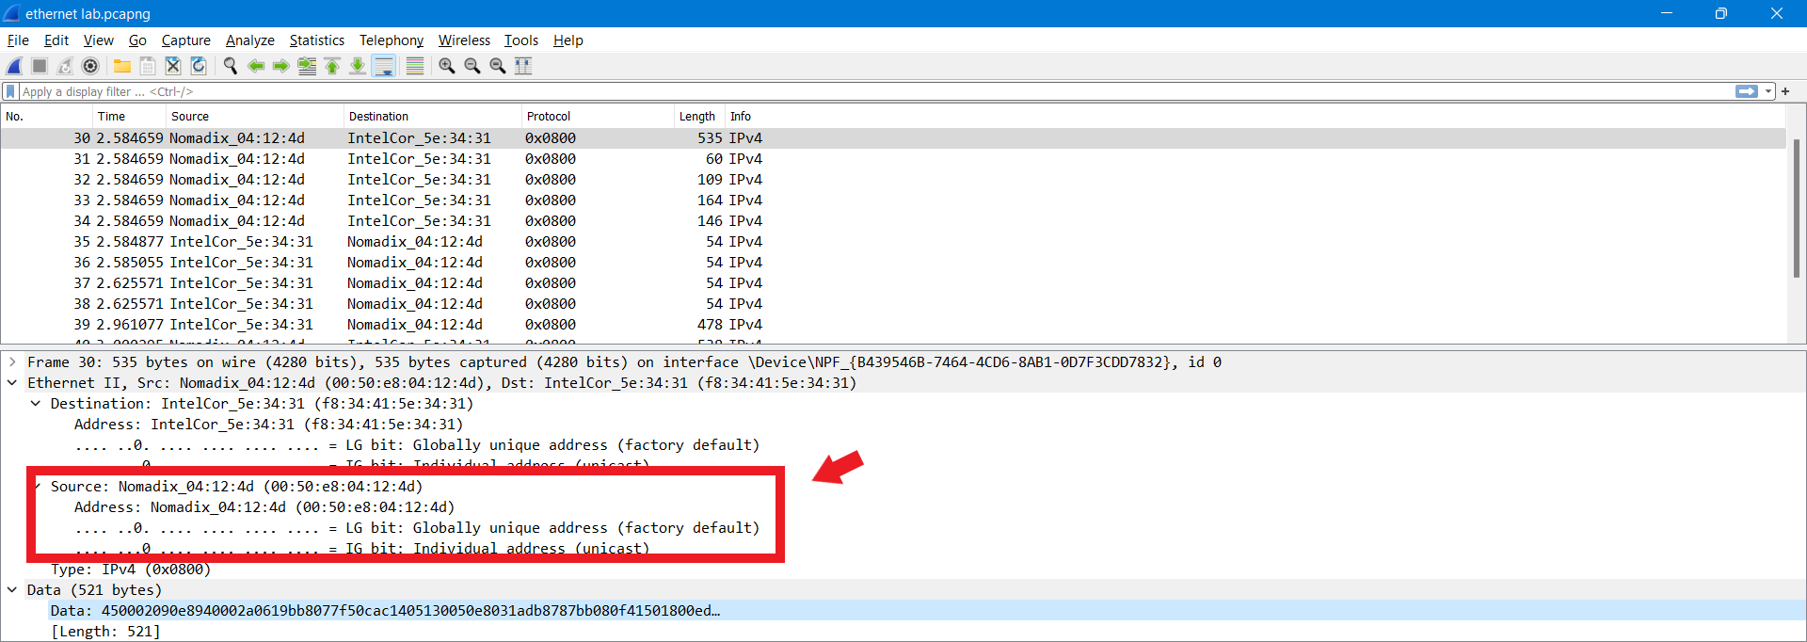

1. The destination address in the Ethernet frame is: - f8:34:41:5e:34:31 is the address of my computer.

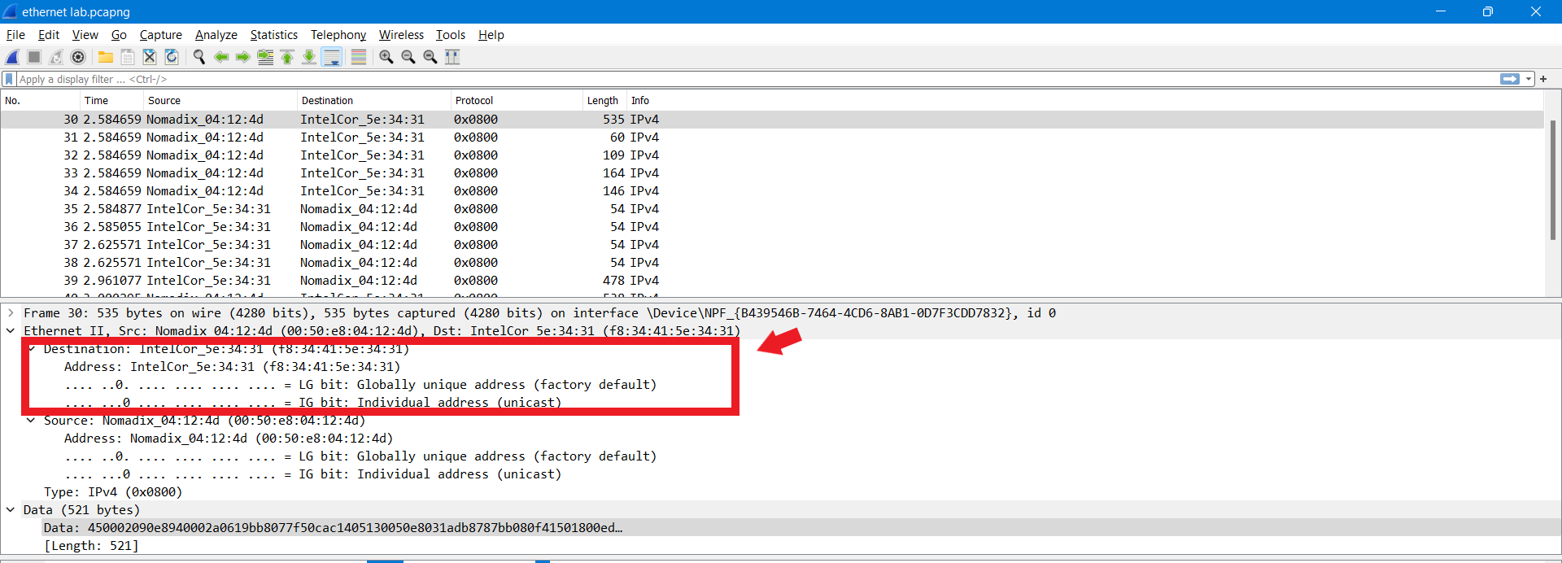

1. The hex value of the frame type field is **0x0800**. This corresponds to **IP protocol.**

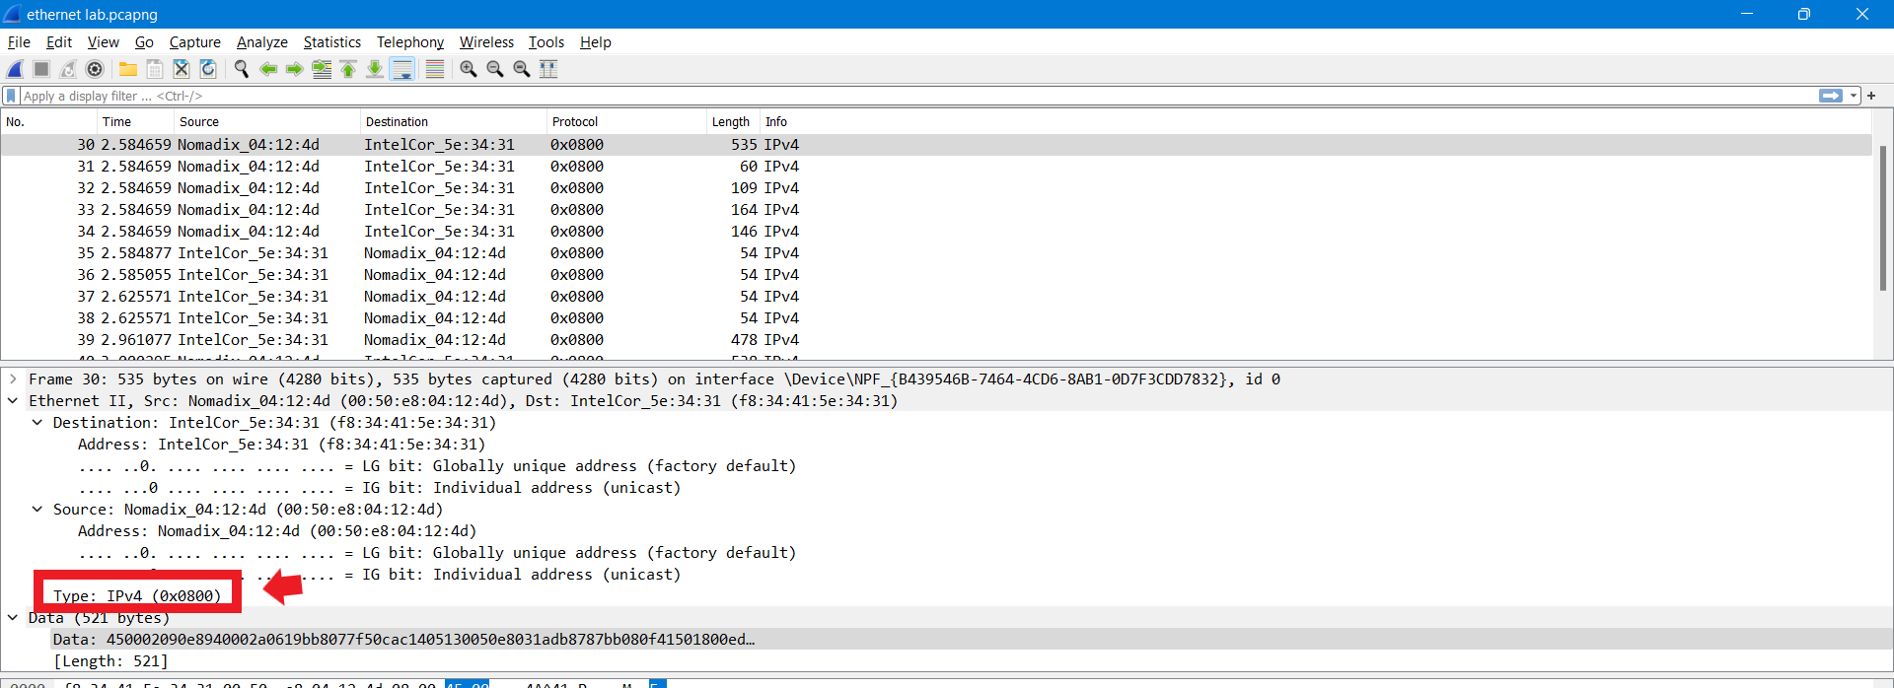

1. The ASCII “O” in “OK” has “4f” bytes from start of Ethernet Frame.

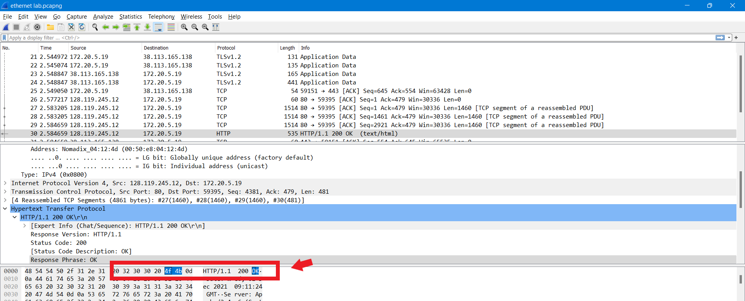

1. The **Internet Address** field contains the IP address, the **Physical Address field** contains the MAC address, and the **type field** indicates the protocol type.

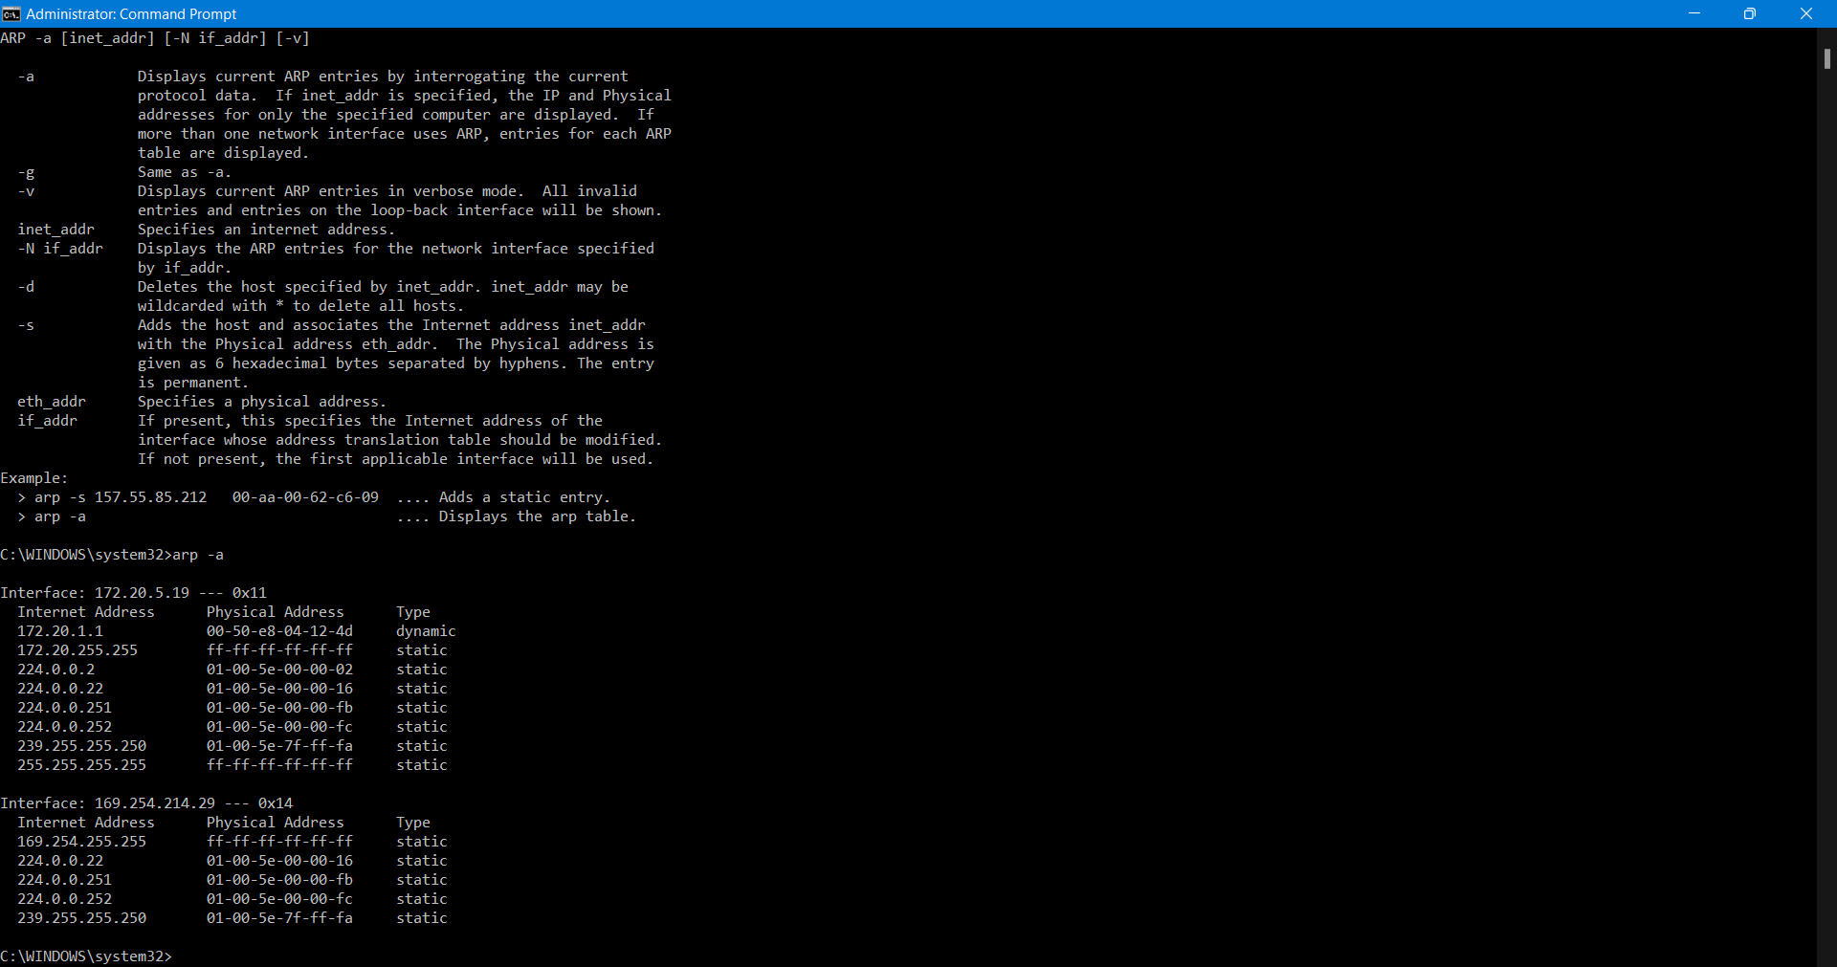

1. The hex decimal value of source is: f8:34:41:5e:34:31

The hex decimal value of destination is: ff:ff:ff:ff:ff:ff

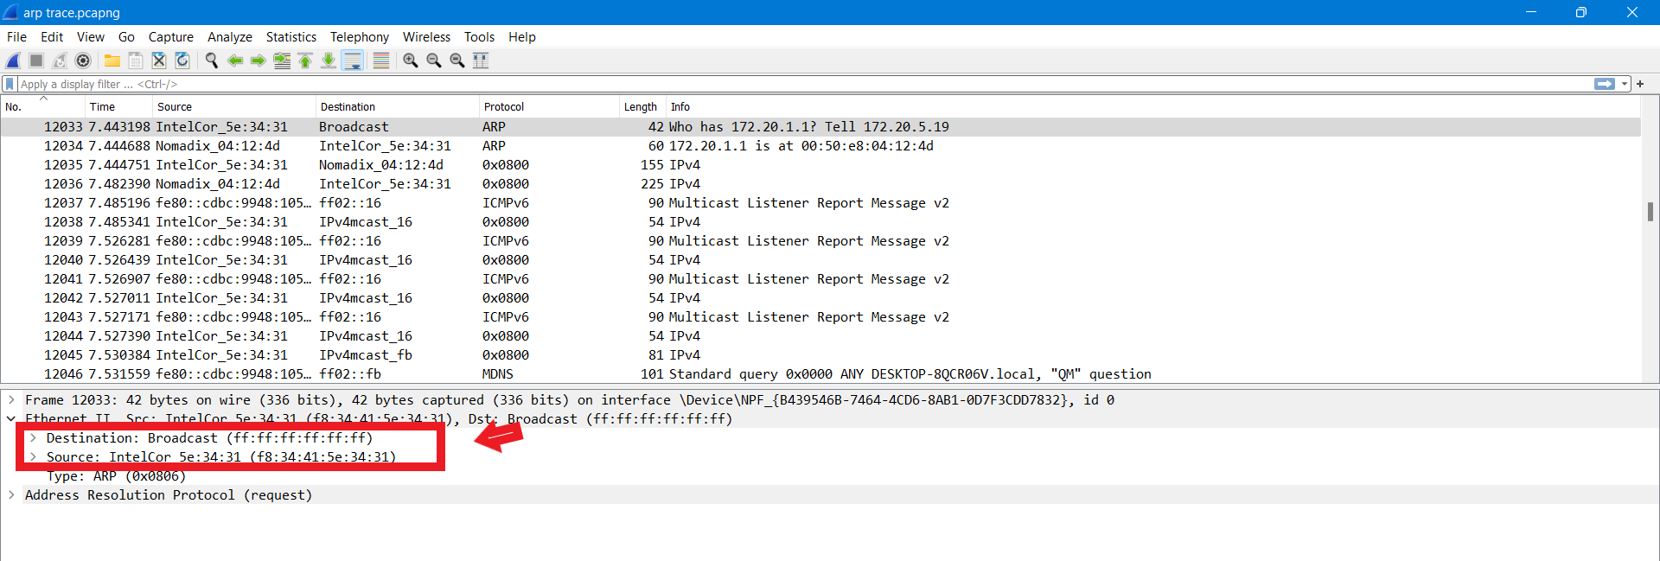

1. The hexadecimal value of the two-byte ethernet frame type field is: - **0x0806.**

It corresponds to **ARP** upper layer protocol.

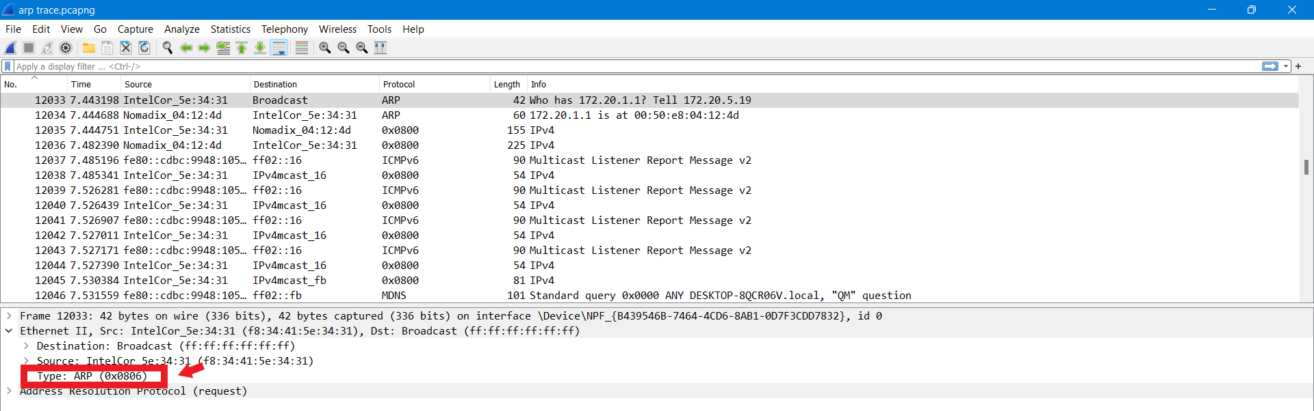

A). ARP opcode field starts 20 bytes from very beginning of the Ethernet frame.

B). The hex value of the opcode field within the ARP payload part of the ethernet frame in which the ARP request was made is **0x0001.**

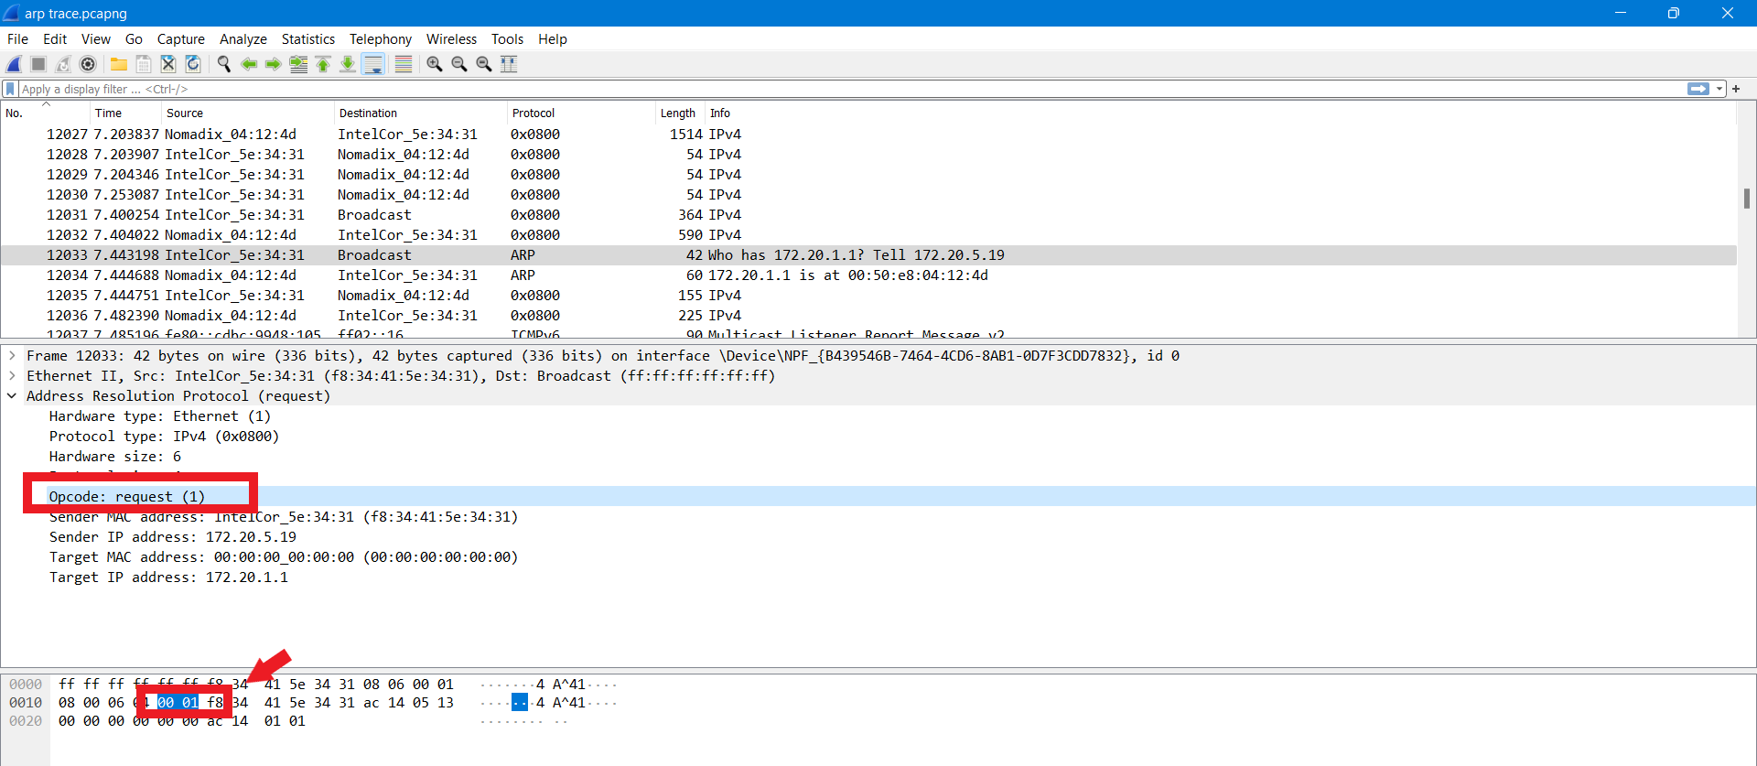

C). Yes, the ARP message contain the IP address of the sender which is – **172.20.5.19**

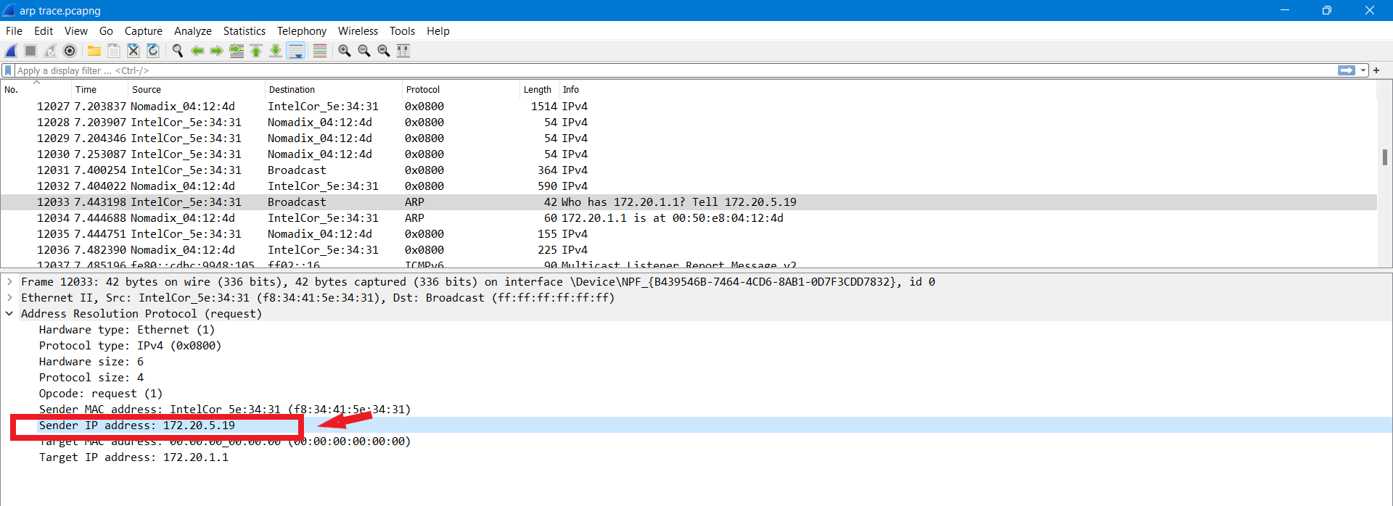

D). The field “Target MAC address” is set to 00:00:00:00:00:00 to question the machine whose corresponding IP address (172.20.1.1) is being queried

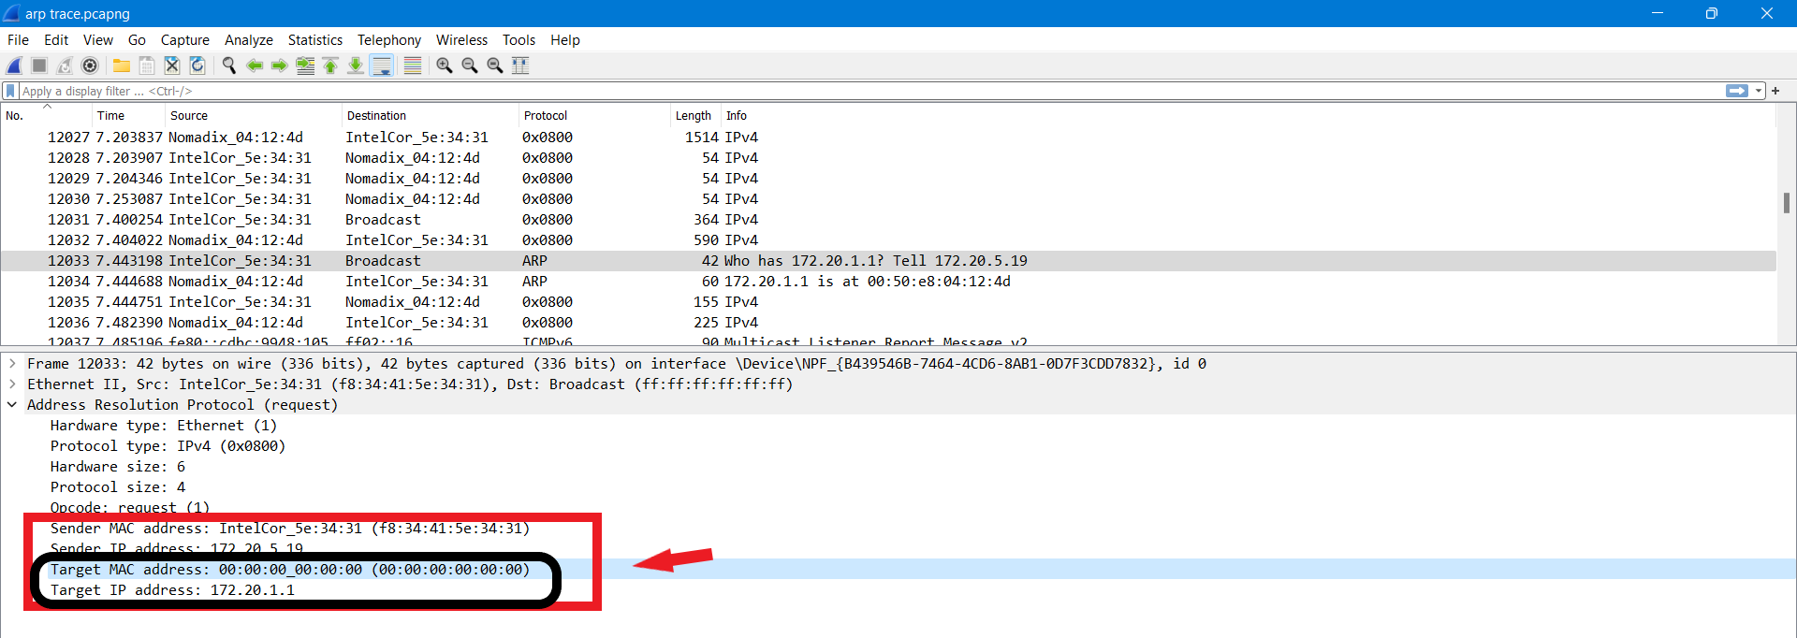

1. The ARP opcode field begins 20 bytes from the very beginning of the Ethernet frame.
2. The hex value of the opcode field within the ARP payload part of the ethernet frame in which the ARP response was made is **0x0002.**

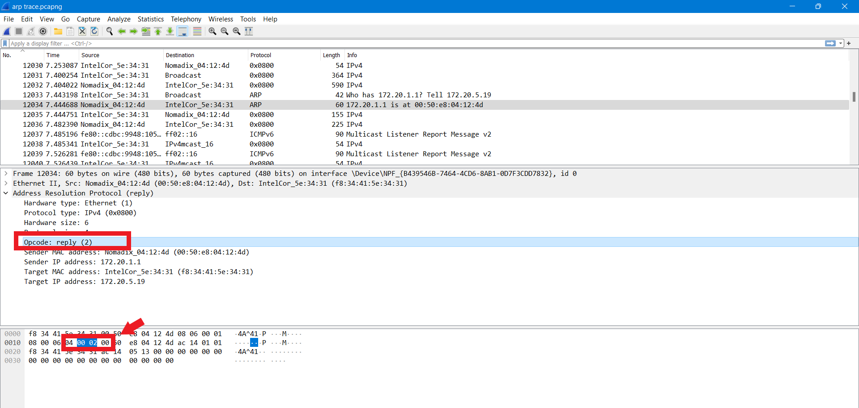

1. The answer to the earlier ARP request appears in the”Sender MAC address” field, which contains the Ethernet address **00:50:e8:04:12:4d** for the sender with IP address **172.20.1.1.**

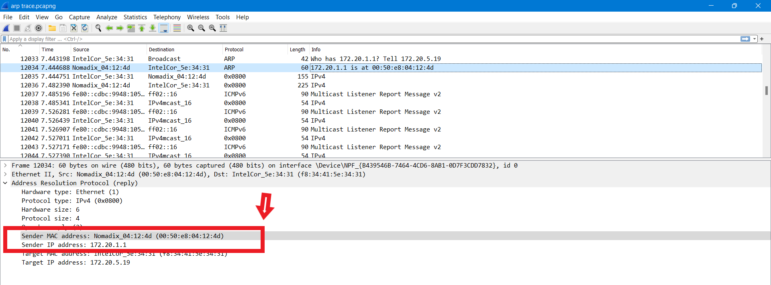

1. The hex value for the source address is 00:50:e8:04:12:4d and for the destination is f8:34:41:5e:34:31 .

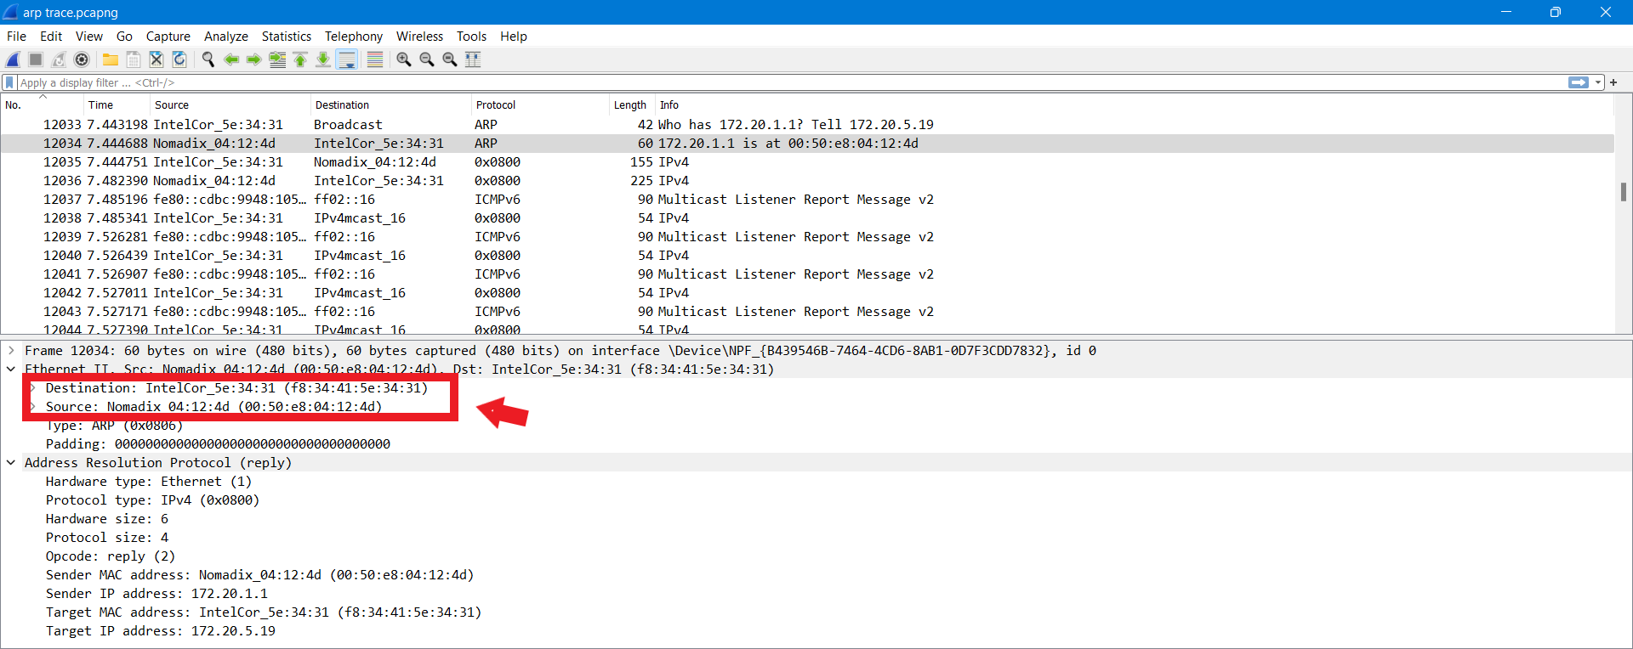

1. Since the ARP request is a broadcast (ff:ff:ff:ff:ff:ff), the ARP reply is directly sent back to the source’s ethernet address. Therefore, there is no reply in this trace, since the machine is not that sent the request but the router.

**EXTRA CREDIT**

**EX-1. The arp command:**

**arp -s, InetAddr EtherAddr, allows you to manually add an entry to the ARP cache that resolves the IP address InetAddr to the physical address EtherAddr. What would happen if, when you manually added an entry, you entered the correct IP address, but the wrong Ethernet address for that remote interface?**

**SOLUTION:** **ARP protocol is used to get the correct address**. Once the router received the destination IP address, even when we have entered an incorrect MAC address, the router will remove IP address from the Ethernet frame and using ARP, would get the correct MAC address of the destination.

**EX-2. What is the default amount of time that an entry remains in your ARP cache before being removed? You can determine this empirically (by monitoring the cache contents) or by looking this up in your operation system documentation. Indicate how/where you determined this value.**

**Solution:** The default amount of time that entry remains in your ARP cache before being removed is 21,600 seconds (6 hours). And we can specify how long an entry needs to remain in the ARP cache using the ARP timeout command.